# HTML5 Assessment Brief

Create a website using HTML5, CSS3 and JavaScript. The website should have the following layout:

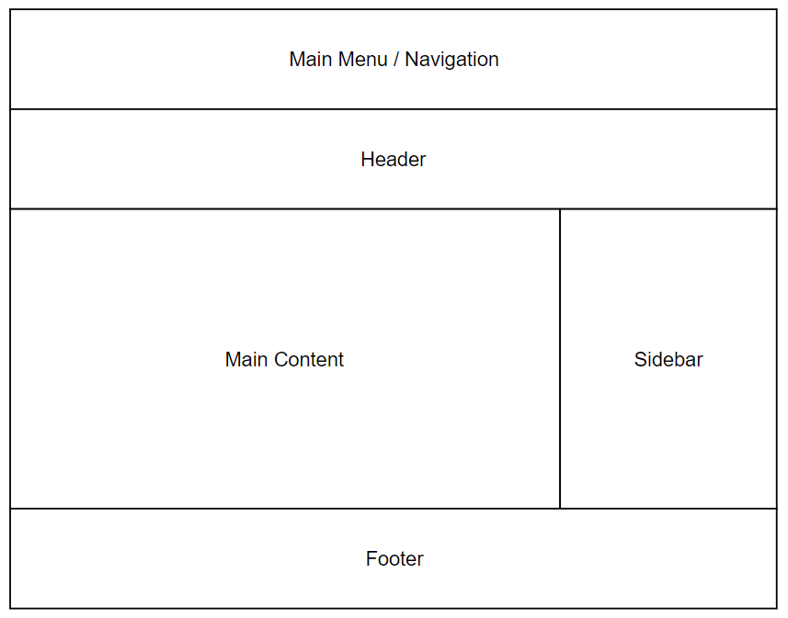

The subject/content of the site is up to you.

It should have a *minimum* of three pages:

Home – A welcome page with some basic information

About – A page detailing some information about the subject.

JavaScript Demo – A page demoing the use of JavaScript. You should be able to demonstrate changing the content of the page using JavaScript. This can be text, colour, size etc. Whatever you like. Your JavaScript demo must make use of the localStorage HTML5 API and make a web service call displaying information retrieved.